CS221 - Section 1 - Homework 2
Burak Öztürk - 21901841

2.1.1. I tested 12 N values. 12345 is chosen to generate more fine outputs like 74074 instead of 58000 just above it.

2. I have written the code and gather resulting output.

3. Table (Time unit is 10^(-6) milliseconds.):

N | Linear (Iterative) |  |  |  | Linear (Recursive) |  |  |  | Binary Search |  |  |  | Jump Search
N | A | B | C | D | A | B | C | D | A | B | C | D | A | B | C | D
10 | 4 | 10 | 18 | 16 | 6 | 20 | 30 | 30 | 8.16 | 9.96 | 12.28 | 11.2 | 36 | 67 | 118 | 143
20 | 8 | 16 | 40 | 40 | 8 | 36 | 64 | 72 | 13.28 | 12.8 | 12.32 | 14 | 39 | 94 | 164 | 182
50 | 10 | 50 | 90 | 100 | 20 | 140 | 280 | 300 | 10.6 | 15.8 | 17.4 | 16.6 | 45 | 130 | 225 | 260
100 | 20 | 100 | 180 | 180 | 40 | 320 | 540 | 580 | 22 | 52 | 15.2 | 19.6 | 70 | 180 | 300 | 320
200 | 40 | 200 | 360 | 360 | 80 | 600 | 1120 | 1240 | 19.2 | 22.4 | 15.2 | 22.4 | 80 | 260 | 420 | 460
500 | 100 | 400 | 900 | 900 | 300 | 1600 | 2900 | 3100 | 28 | 28 | 26 | 26 | 150 | 400 | 600 | 700
1000 | 200 | 1000 | 1800 | 1800 | 600 | 3200 | 6000 | 6200 | 24 | 28 | 32 | 28 | 100 | 500 | 900 | 1000
1500 | 300 | 1200 | 2700 | 2700 | 900 | 4500 | 8700 | 9300 | 24 | 30 | 24 | 36 | 150 | 600 | 1050 | 1050
2500 | 500 | 2500 | 4500 | 4500 | 2000 | 8000 | 14500 | 16000 | 40 | 30 | 30 | 40 | 250 | 750 | 1250 | 1500
5000 | 1000 | 5000 | 9000 | 9000 | 3000 | 17000 | 29000 | 32000 | 60 | 40 | 20 | 40 | 500 | 1500 | 2000 | 2000
10000 | 2000 | 10000 | 18000 | 18000 | 6000 | 36000 | 58000 | 66000 | 40 | 40 | 40 | 40 | 1000 | 2000 | 3000 | 3000
12345 | 2469 | 12345 | 22222 | 22222 | 7407 | 44444 | 74074 | 81481 | 49.3 | 40 | 49.3 | 49.38 | 1200 | 2469 | 3703 | 3703

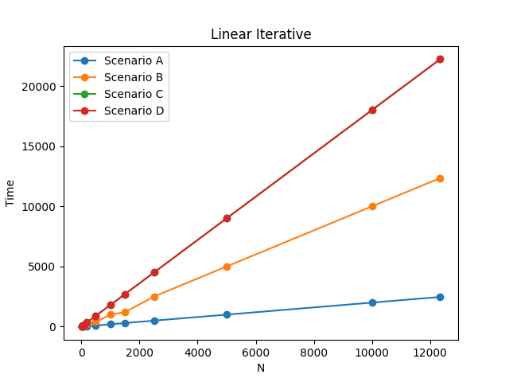
4. Plots:
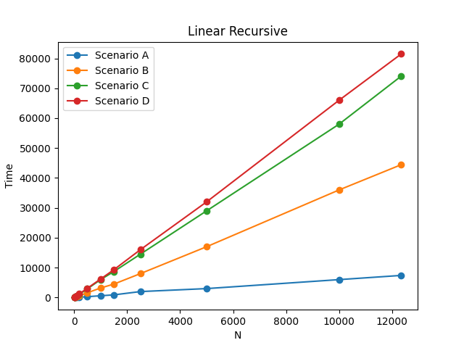
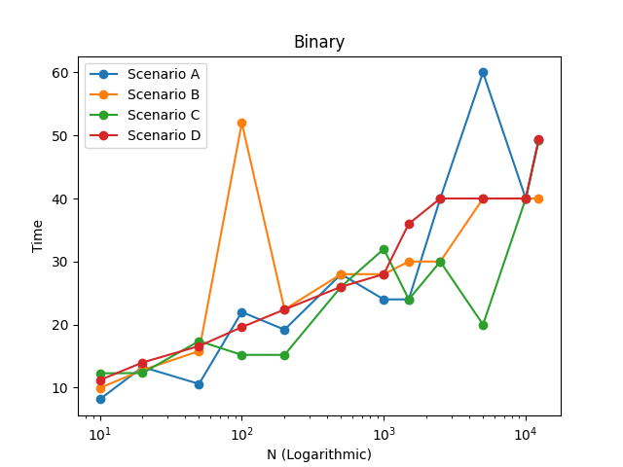
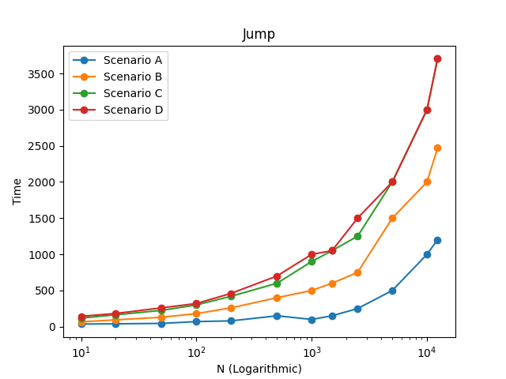
5.1. Specifications of my computer:
Processor: Intel(R) Core(TM) i7-10750H CPU @ 2.60GHz (12 CPUs), ~2.6GHz
RAM: 16384MB
Operating System: Windows 10 Pro 64-bit (10.0, Build 19041) (19041.vb_release.191206- 1406)
Model: MONSTER ABRA A5 V15.8
C++ Compiler: gcc version 6.3.0 (MinGW.org GCC-6.3.0-1)
5.2:
Iterative Linear Search:
Best: value = first element of array | time = 1 comparison time

Average: value = mid element of array | time = N / 2 comparisons (N: array size)

Worst: value = last element of array or value is not on the array
time = N comparisons

Recursive Linear Search:
Best: value = first element of array | time = 1 comparison time

Average: value = middle element of array | time = 3N / 2 comparisons and 3 N / 2 function calls

Worst: value = last element of array or value is not on the array
time = 3N comparisons and 3N function calls
Binary Search:
Best: value = middle element of array | time = 1 search iteration

Average: Value can be anywhere for average case | time = log2(n) search iterations

Worst: value = ⌊log2(n) + 1⌋th element or value is not on the array| time = log2(n) search iterations

Jump Search:
Best: value = first element of array | time = 1 comparison time

Average: value = middle element of array | time = / 2 jumps and / 2 linear search comparisons

Worst: value = last element of array or value is not on the array | time = jumps and linear search comparisons

5.3:
Iterative / Recursive Linear Search:
Best case is always Scenario A for my data for both algorithm. This is expected because linear search will always be faster if target is close to start and that is the case for A.

Average case is B and worst case is C and D for the same reason. In B, target is close to middle and in C, target is close to the end. D is worst case too because algorithm haves to search all the way to the end in that case which is as bad as C. C is little bit faster in my data because Scenario C is causing to search until somewhere close to end and D is causing to search to the very end.

Also recursive implementation is little bit slower than iterative because of all the extra function calls and data transfers that recursion requires.

Binary Search:
Best, average and worst cases are fluctuating for this algorithm because binary search’s speed is determined by being middle element of the array or sub arrays which log2 function but my target selections are based on 10% steps. This makes the results unstable and pseudo-random.

But Scenario D is stable because in that case, algorithm always checks log2(n) terms and that stabilizes measurements. It can be seen in the plot that Scenario D line is the least fluctuatative. Others huge highs and lows.

Jump Search:
Jump search is like linear search++. Best, average and worst cases are same with the linear search but a lot faster. Because of jumps it has O() complexity. Everything else works like linear search and my results are suitable to that.

5.4: Take N = 100 and consistent time requirement for every step of algorithm as 1 ms.
Iterative Linear Search:
Cases:
A = 1 ms | B = 50 ms | C = 100 ms | D = 100 ms

Recursive Linear Search:
Cases:
A = 2 ms | B = 75 ms | C = 150 ms | D = 150 ms
(Slower because of the extra work that recursion requires)

Binary Search:
Cases:
A = 1 ms | B = C = D = log2(100) ≈ 6.64 ms

Jump Search:
Cases:
A = 1 ms | B ≈ 5-8 ms | C ≈ 18 ms | D ≈ 20 ms

Plots:
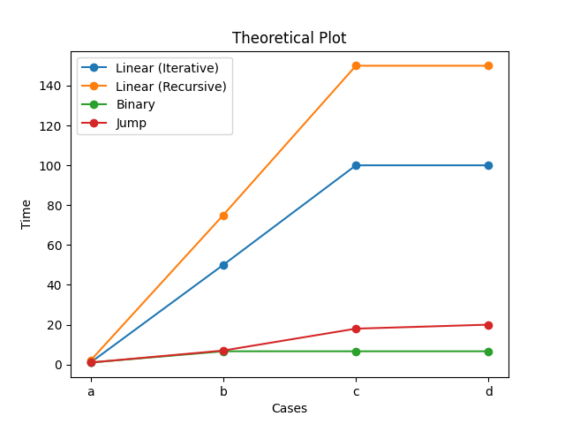
As seen in the theoretical plot above, all algorithms except binary search behaving proportional to my data. This plot is true according to other plots from different sources too besides being much more coarse.

By this theoretical results, I can say my measurements are not too different from real world applications besides binary search’s results with the reason being constant and randomly chosen targets’ effect on binary search algorithm’s way of working.

